**Q-1: what do you mean by an array ?**

Ans: An array is a collection of similar data elements stored at contiguous memory locations. It is the simplest data structure where each data element can be accessed directly by only using its index number.

**Q-2: how to create an array ?**

Soln: **int arr[] = { 2,3,,4,5,6}** define the data type (like int ) and specify the name of the array followed by square brackets []. To insert values to it, use a comma-separated list, inside curly braces:

**Q-3: can we changes the size of an array at a run time?**

Soln: You can not change the size of your array at run time

Q-4: **can you declare an array without assigning the size of the array?**

**Ans: yes**

**Q-5: what is the default value of array ?**

**Ans:**  Since no values are passed during initialization, all elements of the array are set to their default value of 0.

**Q-6: what is a 1d array with an example ?**

Ans:

An array with one dimension is called one-dimensional array or single dimensional [array in java](https://www.scientecheasy.com/2021/08/arrays-in-java.html/).

One dimensional array represents one row or one column of array elements that share a common name and is distinguishable by index values.

**For example,** marks obtained by a student in five subjects can be represented by single-dimensional array because these marks can be written as one row or one column.

***int nums[] = { 30,44,54,63};***

***System.out.println(nums[0]);***

**Q-7: Write an program on a 2d array ?**

**Ans: A multidimensional array is an array of arrays. Each element of a multidimensional array is an array itself. For example,**

**int[][] a = new int[3][4];**

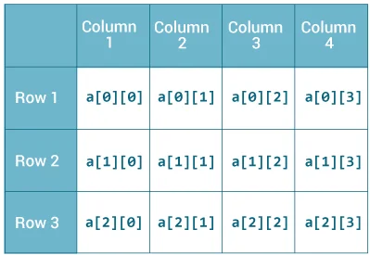

**HERE INITILIZED 2-D ARRAY :**

**int[][] a = {**

**{1, 2, 3},**

**{4, 5, 6, 9},**

**{7},**

**};**

**CODE:**

***int arr[][] = new int[3][4];***

***arr[0][0]= 5;***

***arr[0][1]= 6;***

***arr[0][2]= 7;***

***arr[0][3]= 2;***

***arr[1][0]= 3;***

***arr[1][1]= 5;***

***arr[1][2]= 6;***

***arr[1][3]= 9;***

***arr[2][0]= 9;***

***arr[2][1]= 6;***

***arr[2][2]= 3;***

***arr[2][3]= 9;***

***for(int i=0; i<=2; i++){***

***for(int j=0; j<=3; j++){***

***System.out.print(arr[i][j]);***

***}***

***System.out.println("");***

***}***